Mapping of Ward Boundaries
with JOSM and source images in PDF-format
I) Install the plugin PICLAYER
a) go to Edit / Preferences (See Image)
b) Click on „Configur available plugins“ (1)
c) scroll to PICLAYER and choose it (2)
d) „Update plugins“ (3), then restart JOSM
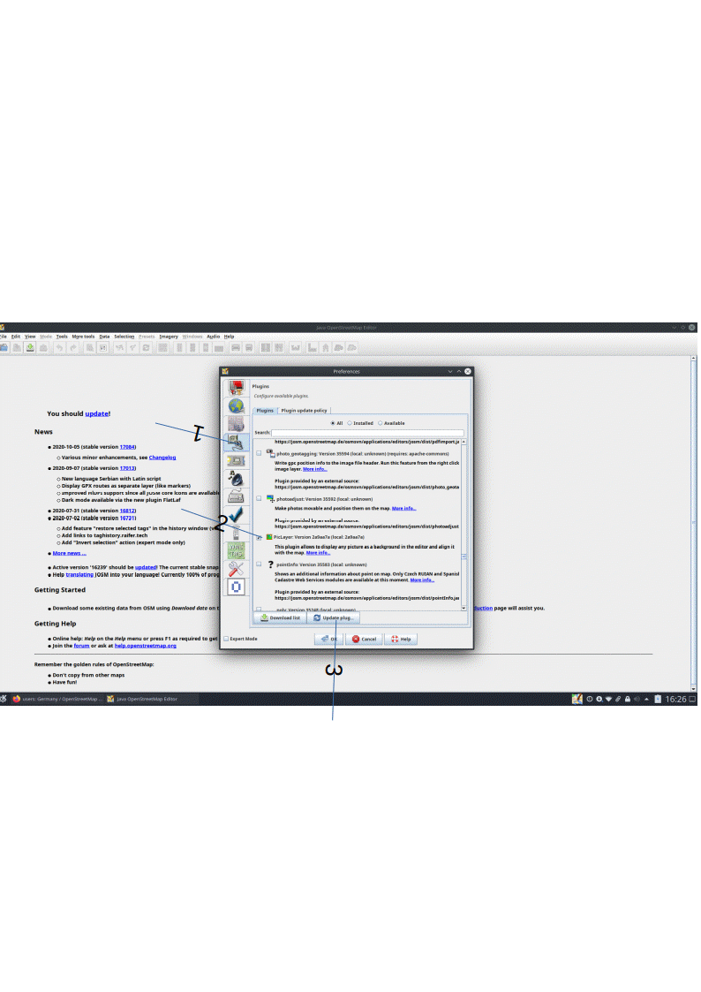

II) Prepare the Image
You find the boundary images as pdf-files. JOSM can not open pdf-files. So you have to convert the pdf to png format. This can be done by one of the online converters. I tried them, but the resulting png-files could not be opened in JOSM.
It is sufficient, if you make a screenshot of the pdf. Screenshots are in png-format. I opened the pdf with libreoffice-draw (you can also use a pdf-viewer), then I made a screenshot (prntscreen) and saved the image in a seperate folder.

III) Mapping with JOSM
For the boundary mapping you only need the already mapped boundaries in the region. Do not download data of the region which is not needed, else it gets too complicated.
I use as an example the boundary map of Ernakulam district (admin_level=5). In this map you see the subdistricts (admin_level=6) and panchayats.. (admin_level=8).

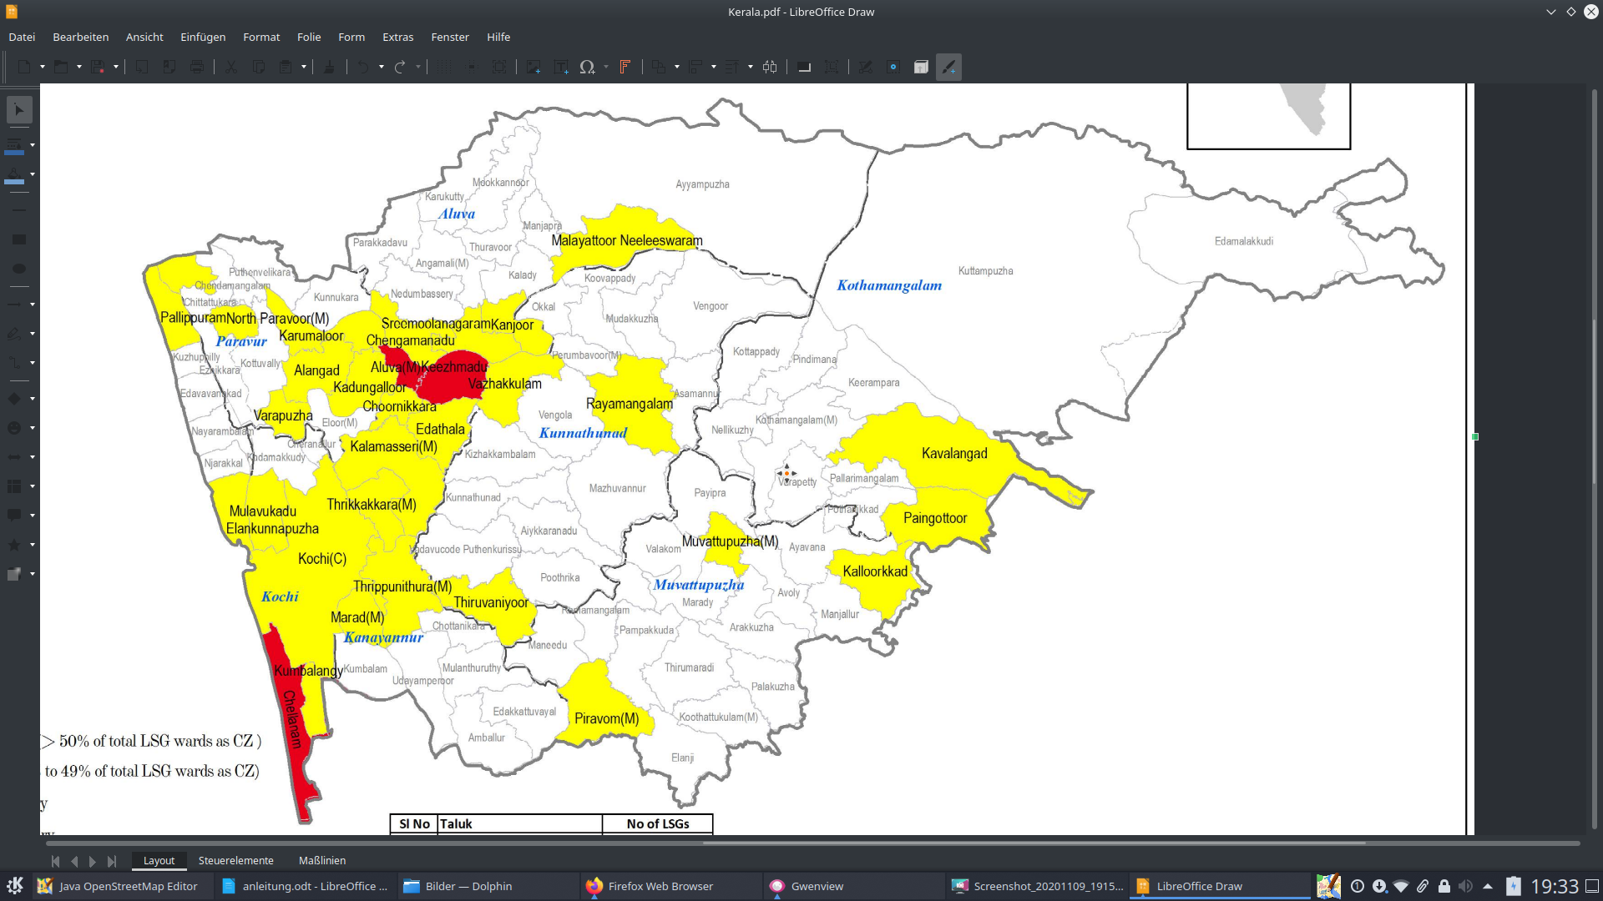
Georeferencing is necessary. That means, the image must be alligned to the already existing district boundary. So I download in JOSM nothing else than these boundaries. You have to activate the expert modus to download data with an overpass query (Edit/references/ bottom of the window).

You see the query in the next image.

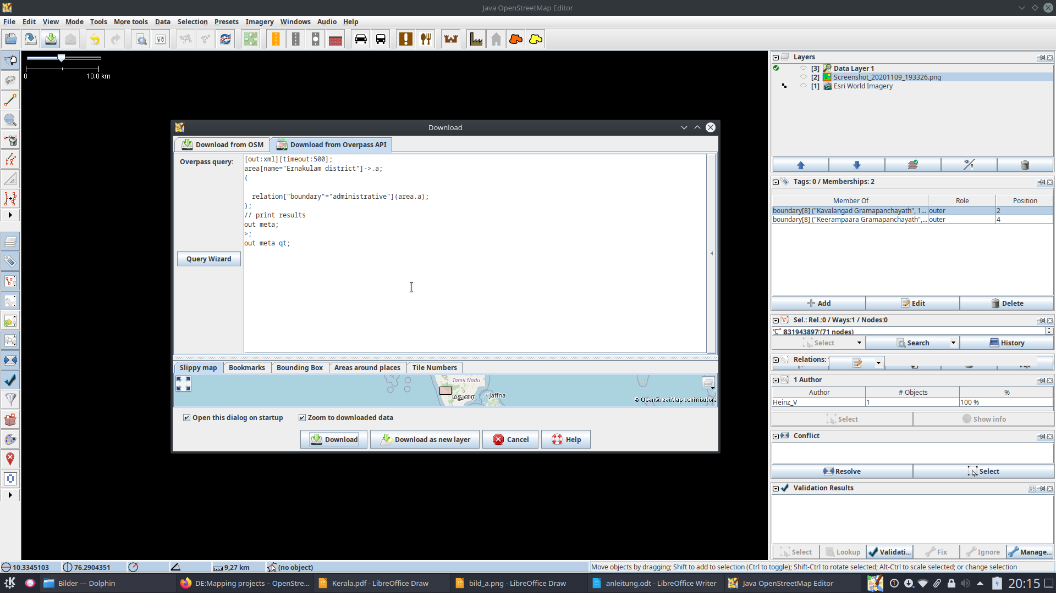

If you want to map wards, then you can use this query:

[out:xml][timeout:500];
// all boundaries in the district
area[name="Ernakulam district"]->.a;
(
nwr["boundary"="local_authority"]["admin_level"="8"](area.a);
nwr["boundary"="local_authority"]["admin_level"="10"](area.a);
nwr["boundary"="administrative"](area.a);
);
// print results
out meta;
>;
out meta qt;

Now you have to load the image in a new layer :
- Zoom to the region where you want to map (here Ernakulam district).
- go to : Imagery/New image from file
- select the saved png-file and open it

You now have the data-layer and the image layer(Screenshot…png).
See next image:

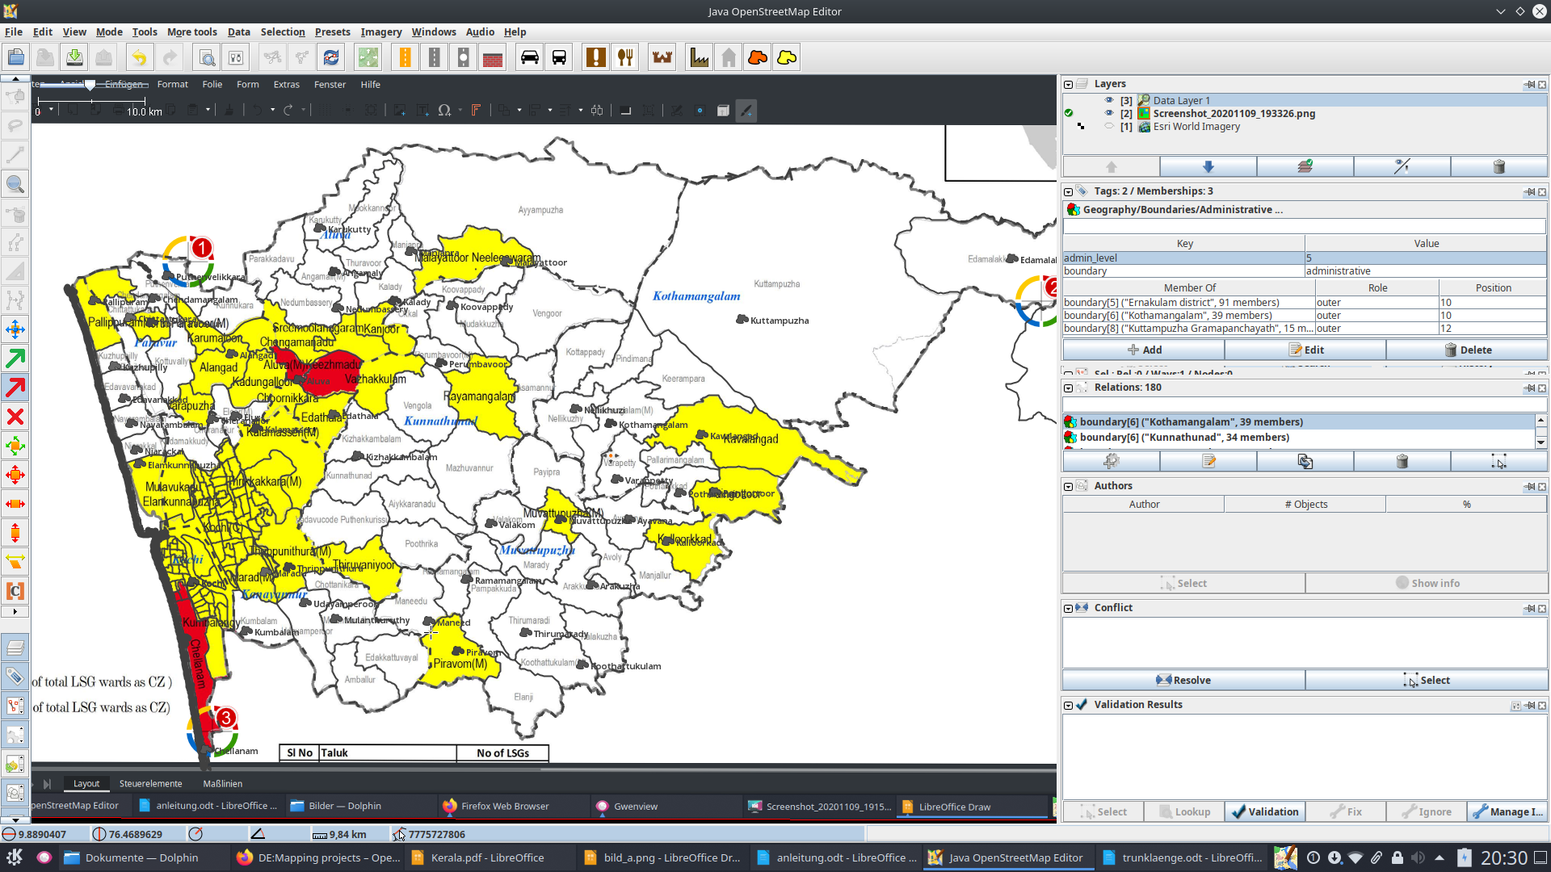
1
2

Position 1 : the image layer is active; in the left toolbar (position 2) there are now some buttons for the work with the image. You can move the image, rotate it (if it is in landscape modus), scale it horizontal and vertical…
Most important are the two arrow buttons:
green arrow active : you set 3 markers (you see, I have 3 markers set(crosses with circle and number)
red arrow active : move to the centre of a marker; hold left mouse button and move the marker
So the whole image get stretched and you can move the image point at the marker to the corresponding point of the boundary in the data layer

Do this with the 3 markers. Maybe you have to switch sometimes from the set-mode(green arrow; for moving the marker to another point ) to the stretch-mode (red arrow to stretch the image).

Finally the image fits to the boundary of the data layer. That means the georeferencing is finished.

Now you can start mapping the new boundaries.

Mapping the new boundaries :

Activate the data layer (you still see the the image)

- Map each boundary with a relation (type=boundary and other tags)
If you map ward-boundaries, then each boundary way is part of two ward-relations (except at the outer boundary of the district, state or nation)
- do not use already existing ways for the boundaries: Then the risk for boundary errors caused by ID mappers or Newbies is nearly 100%!! Also do not use river ways as a boundary: rivers may change but the boundaries normally do not.
- before upload : check if the boundaries are without errors (Select the boundary; then validation)
- if you change a way that is a member in a relation (boundary or else) : take care that you download these relations completely. Else you make relation errors!

Check whether your mapping is without errors!
From the next day on you can do this with : http://tools.geofabrik.de/osmi/ (OSM Inspector)
Select here „area“.

